HTML page using Angular.js

**Requirement1:** **You have to create below screen. Basic HTML is already on place, you have to write events for them.**

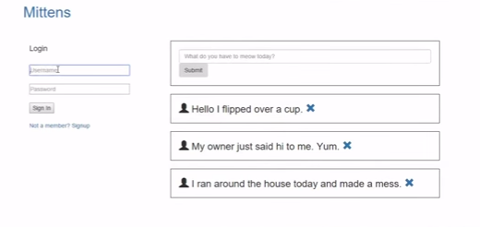

To achieve this, below recipes need to be follow.

Recipe1: Serving a Static Folder from a NodeJS ExpressJS Server

Recipe2: Display meows from mongo dB using GET api.

Recipe3: Insert Meows through application.

Recipe4: Delete Meows through application.

Let’s start with these recipes.

**Recipe1:** **Serving a Static Folder from a NodeJS ExpressJS Server**

Add app.use(express.static('public')); in server.js file.

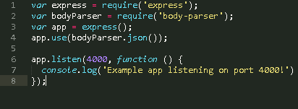

Restart your server by typing $ nodemon server.js in command prompt.

Now you can see mittens application on browser by typing <http://localhost:4000>

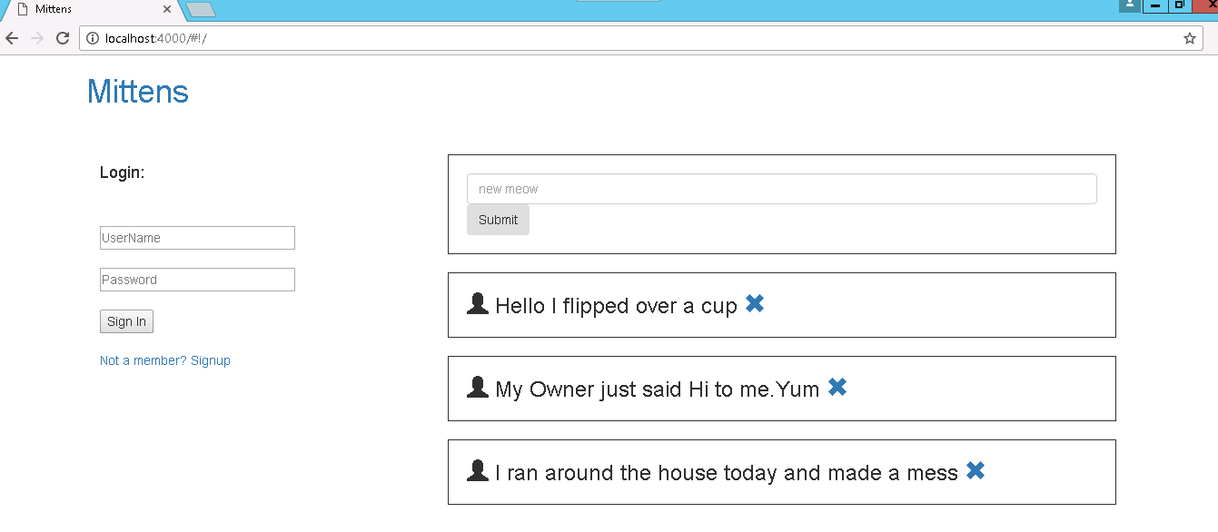

**Recipe2:** **Display meows from mongo dB using GET api.**

Add below code inside home controller in index.html

function getMeows(){

$http.get('/meows').then(function(responce){

$scope.meows=responce.data;

});

}

getMeows();

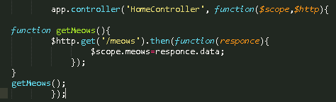

In Home.html remove all <h3> and write below code.

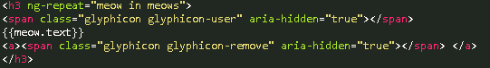

ng-repeat in Angular is similar to foreach loop. The ng-repeat directive repeats a set of HTML, a given number of times. The set of HTML will be repeated once per item in a collection. The collection must be an array or an object.

In server.js file add below code to connect with database.

C:\Users\462439\Desktop\7.PNG

Now we are connected to our database, let’s create a mongoose model and Get operation for meows.

var Meow = mongoose.model('Meow', {

text: String

});

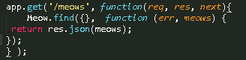

Save it, and run through browser.

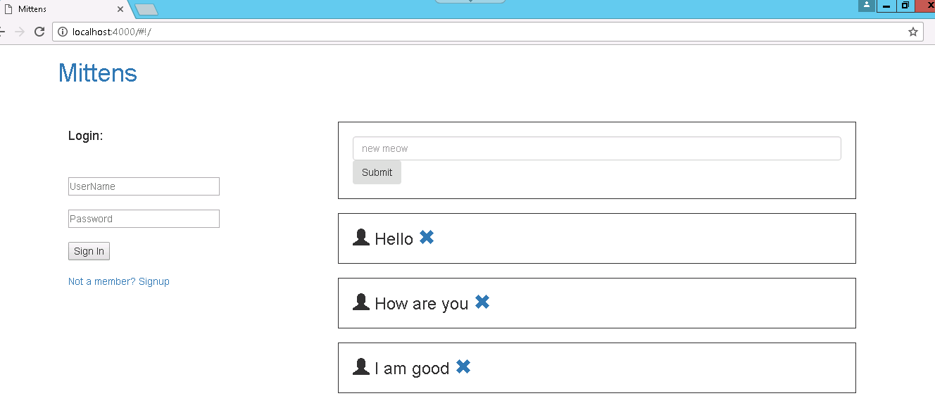

Hurray! It’s working. It displaying data from database

**Recipe3:** **Insert Meows through application.**

Add Click event on submit button in home.html

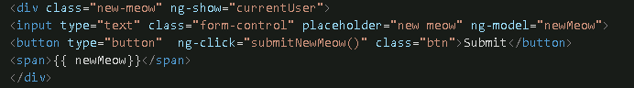

Inside home controller in index.html, implement submitNewMeow() function.

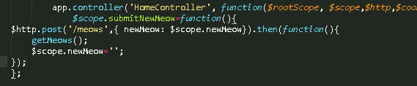

In server.js file add POST method as below for simplicity.

app.post('/meows', function(req, res, next){

var newMeow = new Meow({

text: req.body.newMeow

});

newMeow.save(function(err){

return res.send("Added Successfully");

});

});

Save it, and run through browser.

Write new meow in textbox and click on submit button.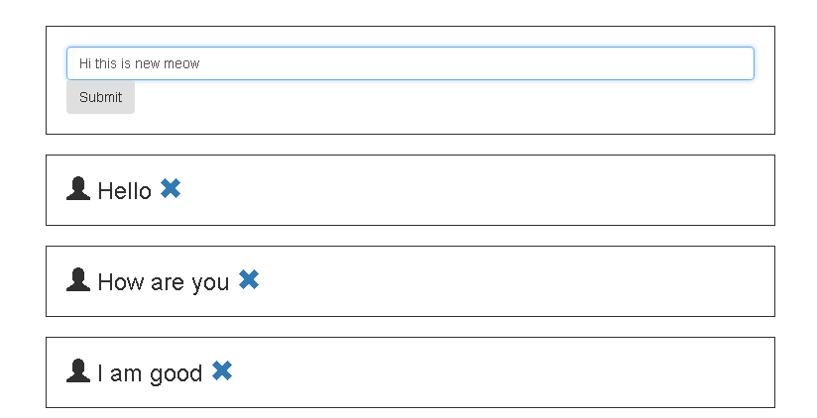

After click on submit button new meow is added successfully.

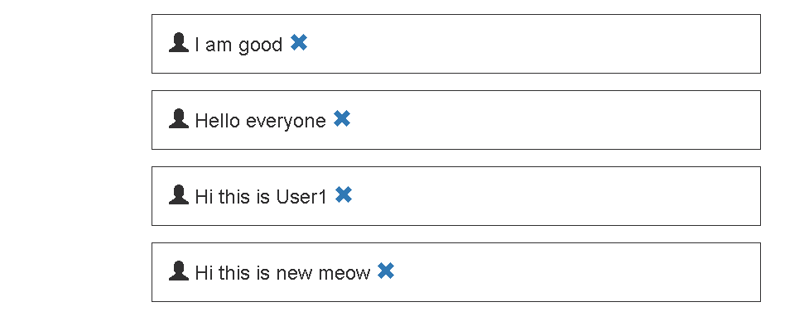

**Recipe4:** **Delete Meows through application.**

Inside home controller in index.html, implement removeMeow function.

$scope.removeMeow=function(meow){

$http.put('/meows/remove',{ meow: meow}).then(function(){

getMeows();

});

};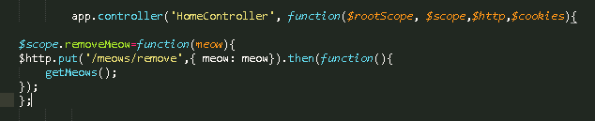

In server.js file add PUT method as below for simplicity.

app.put('/meows/remove', function(req, res, next){

var meowId=req.body.meow._id;

Meow.remove({_id: meowId}, function(err){

return res.send("Deleted Successfully");

});

});

Save it, and run through browser.

Click on cross button to remove meow.

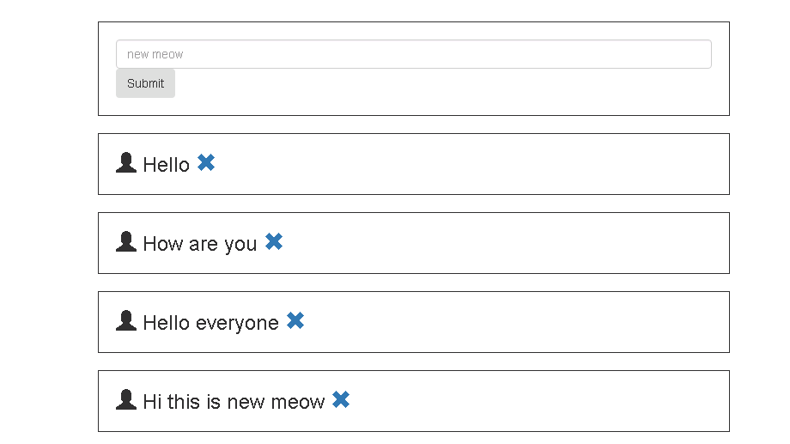

Wow now you can delete any records.

**Happy Coding ☺**